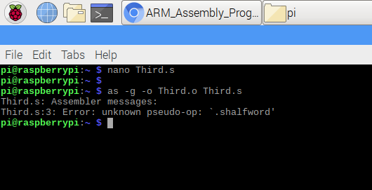

By compiling the program, we see that when we declared the memory “a”, we used incorrect type. In order to store a 16-bit signed integer, we need to use hword instead of shalfword(not exist).

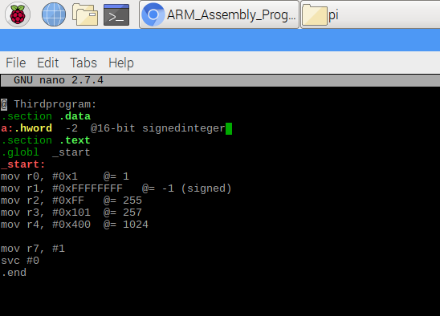

After we changed its data type, we successfully compiled.

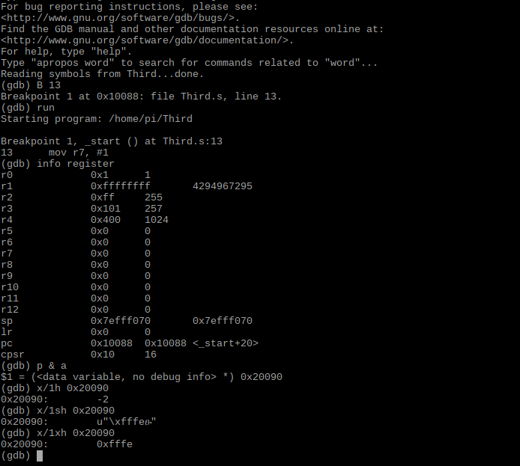

In gdb, we tried x/1h first. This will display the size of “a” in halfword,and we have -2, which is correct as we signed its number in the code. Next, we tried x/1sh, this will display halfword in string. When we tried x/1xh, we have the -2 in hexadecimal format.

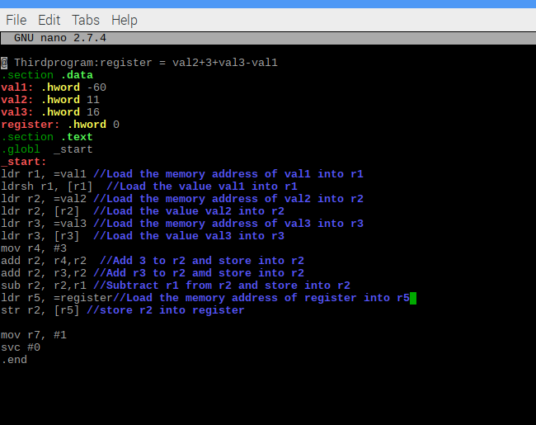

Here we have the program for expression:register = val2+3+val3-val1.

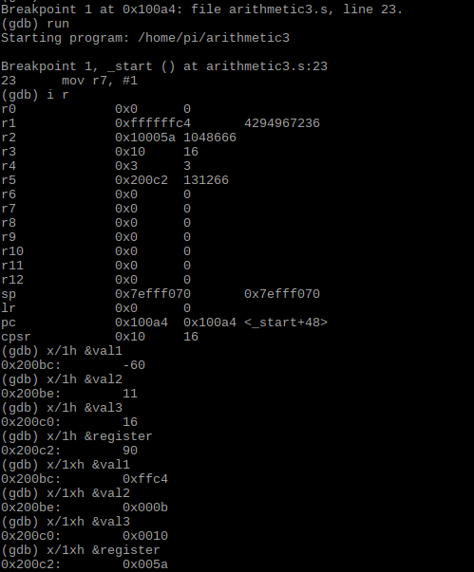

In gdb, we can see all the value of each memory. However, as we see the halfword in hexadecimal of val1, which is ffc4, we can see the sign flag ff, ff means its negative and C4 is 60.